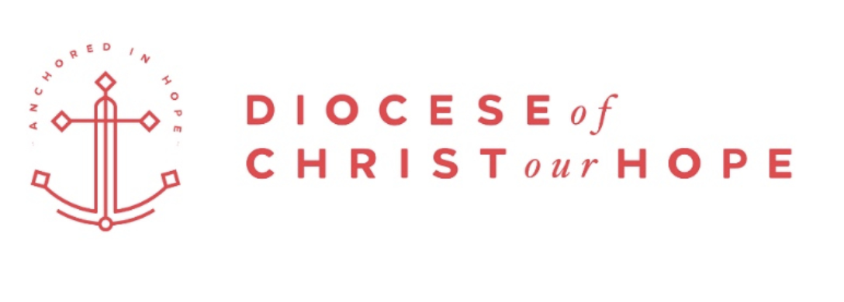
Report to the 2017 Synod of the Diocese of Christ our Hope, ACNA
The Rev. Jeff Weber
Chancellor, Diocese of Christ our Hope

As we enter into our second year as a diocese, it continues to be my privilege to serve as your Chancellor in carrying out our mission to plant, equip, and multiply disciple-making Anglican churches, and to support and serve their people and leaders in Christ life and ministry.

General Counsel
The Chancellor’s office interfaces with a wide variety of teams with a focus on policy, polity and protection in order that the local church, the primary agent of mission, can be fully released to carry out its calling, all the while enjoying the benefits of the collective wisdom and protection of the larger diocesan community. We also provide general counsel to the Bishop and Diocese on a wide variety matters. If you know of attorneys in your local congregation that might be willing to assist in matters from time-to-time within their area of expertise, please have them contact me at jeff@communitasnetwork.org or Ben Bowman at bbowman@adhope.org.

Collaborative Leadership Development
Over the course of this last year, we formed a collaborative group within the ACNA called The Anglican Lawyers Network, with the goal of better serving the local church. The purpose of this group is to provide collaborative environments where resources, documents, and policies can be shared, as well as allow for continual interaction around topics and issues related to provincial, diocesan and parish matters. Tying together all of the ACNA Chancellors, as well as networking the broader group of Anglican lawyers across the country, will allow for an enormously helpful exchange of information that will, in turn, allow us to better serve the local parish. This group was formally recognized this year at the National Conference of the Christian Legal Society where we had our second face-to-face gathering as Chancellors and Anglican lawyers. If you know of any attorneys in your congregations that might be interested in participating, please have them contact me at jeff@communitasnetwork.org or the Rev. Canon Phil Ashey (pashey@americananglican.org) with the American Anglican Council.

Risk Management
This coming year, the Chancellor’s office aims to make a comprehensive review of all areas of risk management in an effort to prioritize and develop training and resources to serve the local church. We invite your input and participation as these areas of focus unfold, calling for unique areas of expertise.

Child Safety and Protection
This last year, the Chancellor’s office began the development of protective and preventative approaches to specific risk management areas. Primary to our focus this year was laying the foundation for implementing a preventative approach to safeguarding the children and youth entrusted to us. We completed a draft Policy Manual for the Safety and Protection of our Children covering the following areas:

- Selecting and Screening Church Workers
- Supervising Church Staff and Volunteers
- Training Staff and Volunteers
- Interacting Procedures
- Monitoring Procedures
- Responding and Reporting Procedures
- Documentation Protocol

While no single resource can be completely comprehensive, the purpose of this manual is to increase our sensitivity to the importance of this topic and to provide instruction to the clergy, laity and churches of our diocese that will inform our decisions and methods as it relates to the protection of our children and youth. Following reviews by our Bishop and Diocesan Council, the draft will be made available to all diocesan clergy as well as those serving in children and youth ministry. The policy manual will be released on or about January 15, 2018, in draft form for your review and comments.

Safety and Security
Safety and security is another specific focus area of risk management that is underway. We are grateful to have Ted Baltes leading this Task Force as part of the overall risk management strategy being developed by the Chancellor’s office. If you know of someone interested in serving in this area, please have them contact Ben Bowman at bbowman@adhope.org.

Ecclesiastical Trial Court
This year we begin the process outlined in our Constitution and Canons of constituting the diocesan Ecclesiastical Trial Court for the application of church discipline in accordance with the Constitution and Canons of the Province and of the Diocese. The court will consist of nine members elected by the Synod of the Diocese upon the nomination of the Diocesan Council for a term of three years. Four members shall be chosen from the laity and five from the clergy. No member may serve more than two consecutive terms. Staggered terms may be provided. The Diocesan Council fills vacancies that arise between Synods. If you are interested in being considered for service on this court, please see the sign-up sheet while at Synod. After Synod, you can let Ben Bowman know of your interest. He can be reached at bbowman@adhope.org.

Parish Bylaw Guidance
This year, the Chancellor’s office began work on model bylaw language in order to offer guidance to churches in areas of rapid cultural change such as marriage and sexuality. While we see the immediate need for such guidance, there is simply no quick path to theologically sound and protective bylaw language without gathering the wisdom from a broader base within the ACNA. This includes the Governance Task Force and College of Bishops. Additionally, the Province’s newness requires a deeper understanding of the decision-making pathway that gives meaningful participation of the whole Church in the drafting and amendment of ACNA Constitution and Canons which, in turn, lead to a deeper and more uniformed guidance to the local church that is sourced in the collective wisdom of the church. This is currently being worked through as well. While the principles of subsidiarity we cherish as Anglicans can be a source of frustration, I pray we find its gift in slowing the cadence of decision making which might otherwise disrupt a much-needed gestational process.

Thank you again for allowing me the privilege of serving you, and please don’t hesitate to contact me if we can help you in any way.

Rev. Jeff Weber, JD
Chancellor, Diocese of Christ our Hope

